Paediatrics

Abstract
Data on 8,246 paediatric cystic fibrosis patients in the UK who attended an annual review between 2007 and 2023 was provided by the CF trust. In total data from 62,940 annual reviews was provided. Data included BMI z-score and centile, along with lung function and modulator status. We found that the proportion of overweight and obesity is increasing. In 2007 14.2% of paediatric patients were overweight or obese, compared to 22.7% in 2023. Higher BMI z-scores are associated with better lung function. Increasing BMI has the largest effect in underweight patients. FEV in patients with high BMI (z-scores greater than 1) were not significantly different to FEV in patients with healthy BMIs (z-scores of 0). There is strong evidence that modulators have changed this association. Patients on modulators have higher FEV than patients not on modulators (p < 0.001) and increasing BMI has a smaller, but still positive, effect (p < 0.001).

Methods
Data was provided from the CF trust on 8,246 cystic fibrosis patients aged 2-17 who had an annual review between 2007 – 2023. Patients did not have to attend each annual review, and the median number of annual reviews attended is 12. Weight categories were assigned based on BMI percentile (as recorded in the registry data) following WHO guidance (?). Patients are classed as underweight if their BMI is below the 5th centile for their age & sex, healthy weight if their BMI is equal to or above the 5th and below 85th centile, overweight if their BMI is equal to or above the 85th centile and below the 95th centile, and obese if their BMI is equal to or above the 95th centile.
There were 31,474 reviews which did not have BMI percentile recorded. If BMI or weight & height was recorded for these reviews, BMI percentile was calculated using the NHS BMI calculator.
Two descriptive charts were produced. One is a reproduction of Figure 1 in Szentpetery et al, examining trends in the proportion of patients in each weight category over time. The other is a plot of BMI Z-scores against FEV1. A lowess smoother was fit to the data to show the overall association.
Linear models were fit to examine the association between weight gain and lung function. Current FEV1 was modelled based on the patients BMI in the previous year, the change in BMI between the previous year and the current year, the previous FEV1, the number of microbiology cultures recorded in the previous year, if the patient was receiving pancreatic enzyme supplements in the previous year, age, and sex. BMI was modelled as a natural cubic spline, and an interaction was included between the BMI spline and change in BMI to allow the effect of changing BMI to vary at low and high BMI values.
To examine if modulators have changed the association between weight gain and lung function another interaction term between modulator status (on / off modulator at the time of review) and change in BMI was included.

Results
We find that the proportion of overweight and obese paediatric patients has increased over time, with most of the increase occurring after 2017. In 2007 14.2% of paediatric patients were overweight or obese, compared to 22.7% in 2023. Figure 1 below shows the trend in weight categories over time. Note that there is a potential data issue in 2017 where the BMI percentile values are lower compared to other years. 2017 has been included on the chart but should not be interpreted:
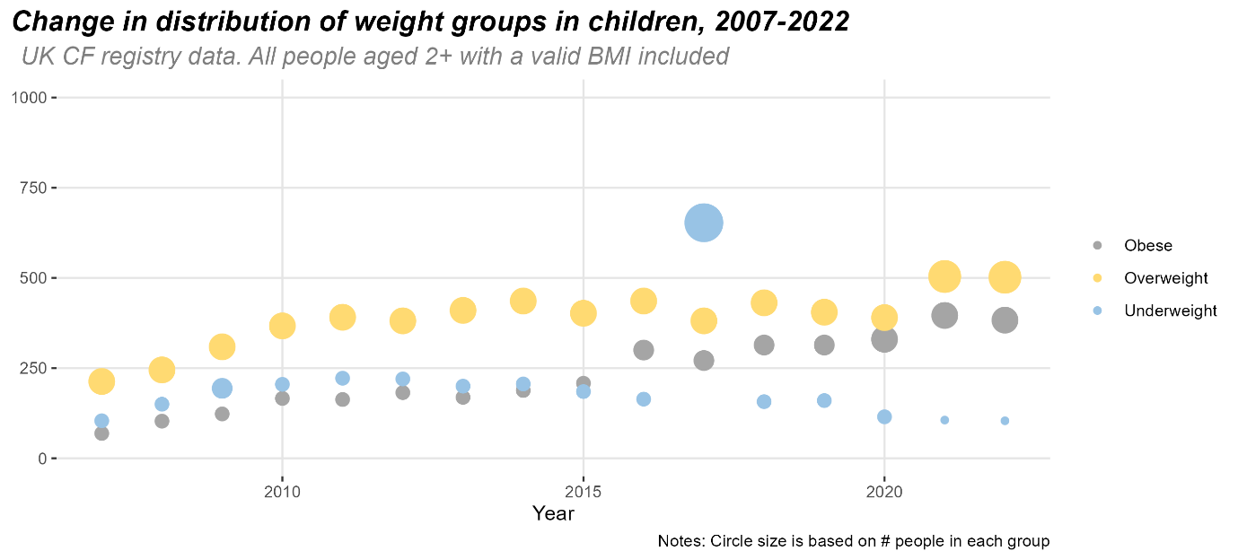
Figure 1: Timeseries of weight categories, paediatric CF patients between 2007-23
Higher BMI Z-scores are associated with better lung function, as measured by FEV1. Increasing BMI in underweight patients has the strongest increase in lung function. Increasing BMI in healthy weight patients (z-scores of zero and above) is associated with a much smaller increase in FEV:
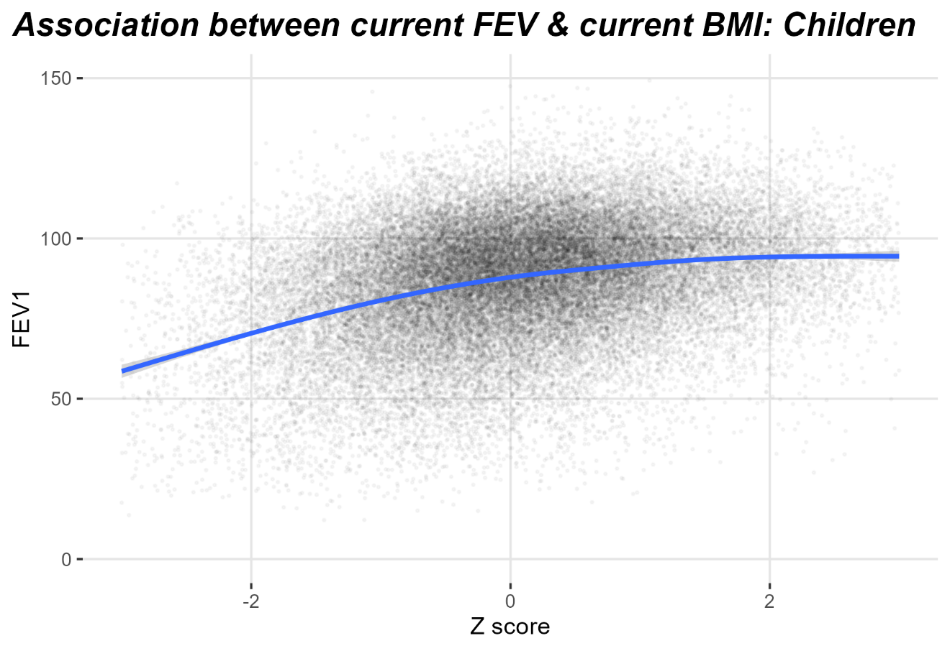
Figure 2: Association between lung function and BMI. Dots are BMI z-score and FEV1 as recorded at each annual review in the CF trust data. The blue line is a lowess smoother showing the general trend in the data.
Figure 3 shows how changing BMI affects FEV1 in more detail. Large increases in BMI lead to the largest increases in FEV1 in the underweight group. In all weight groups the positive effect of increasing BMI gradually declines for large increases in BMI. In the healthy weight, overweight, and obese groups, there is no evidence that increasing BMI by 10 will lead to a significant increase in lung function compared to increasing BMI by 5. We found no evidence that the effect of changing BMI varies by sex.
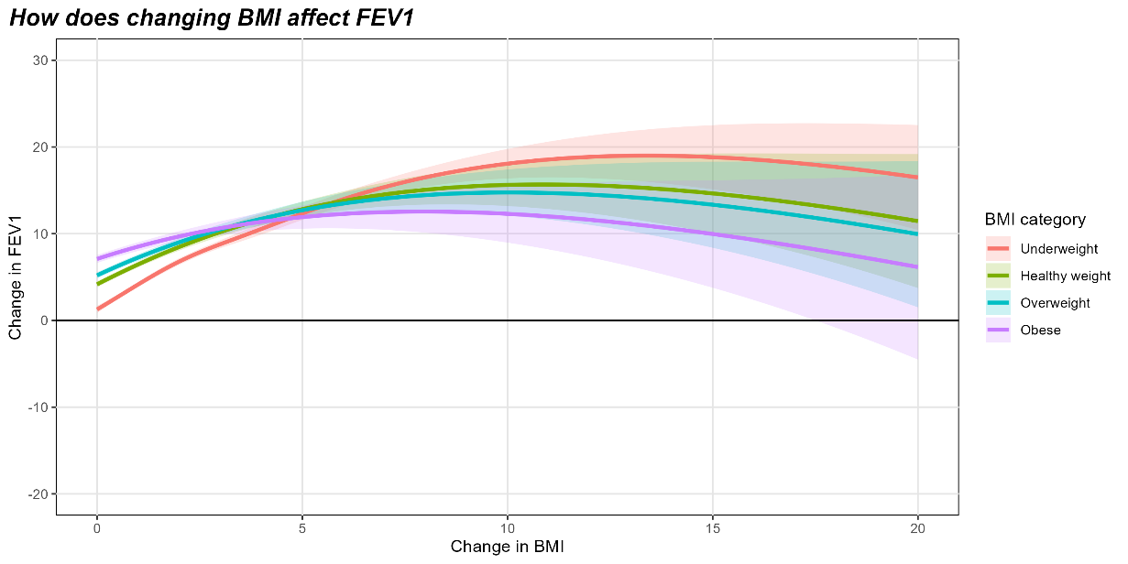
Figure 3: Change in lung function (FEV) as a function of increasing BMI. Solid line shows the predicted change in FEV1 and the shaded regions are 95% confidence intervals.
Being on a modulator at the time of review is strongly associated with higher levels of lung function. Patients who were on modulators at the time of review had a FEV1 3.77 units higher than similar patients not on modulators (95% confidence interval [3.42, 4.12], p < 0.001). There is also strong evidence that being on a modulator changes the effect of increasing BMI on lung function (p < 0.001). This is shown in figure 4 – smaller increases in BMI have more of an effect in people on modulators, and larger increases in BMI are less effective:
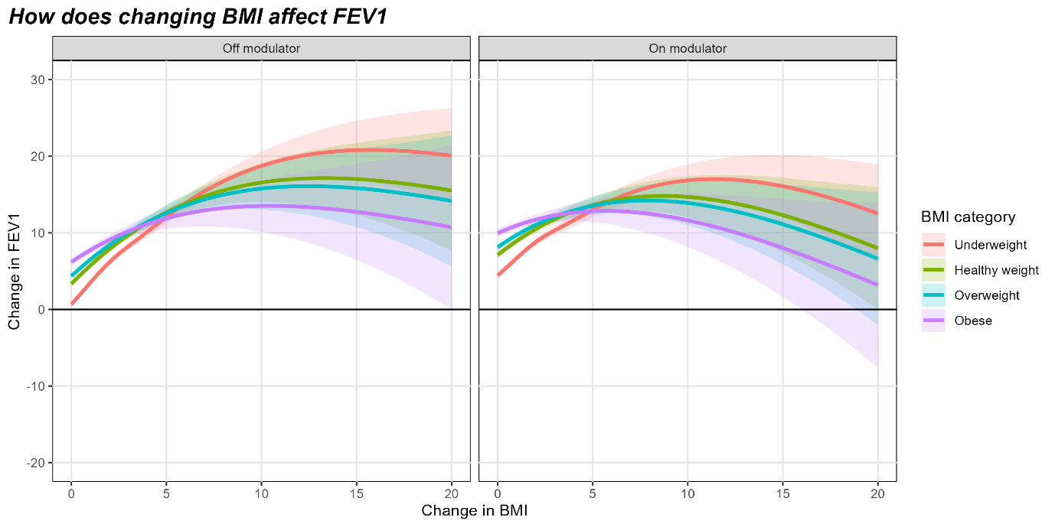
Figure 4: Change in lung function (FEV) as a function of increasing BMI, in patients on and not on modulators. Solid line shows the predicted change in FEV1 and the shaded regions are 95% confidence intervals.

Adults

Abstract
Data on 5,183 adult cystic fibrosis patients in the UK who attended an annual review between 2007 and 2023 was provided by the CF trust. In total data from 82,604 annual reviews was provided. Data included BMI value and centile, along with lung function and modulator status. We found that the proportion of overweight and obesity is increasing. In 2007 17.1% of adult patients were overweight or obese, compared to 37.6% in 2023. Higher BMI values are associated with better lung function. Increasing BMI has the largest effect in underweight patients. FEV in patients with high BMI (greater than 25 kg/m2) were not significantly different to FEV in patients with healthy BMIs (in the 20 – 25 kg/m2 range). There is no evidence that modulators have changed this association.

Methods
Data was provided from the CF trust on 5,183 cystic fibrosis patients aged 18 and over who had an annual review between 2007 – 2023. Patients did not have to attend each annual review, and the median number of annual reviews attended is 12. Weight categories were assigned based on BMI (as recorded in the registry data) following WHO guidance (?). Patients are classed as underweight if their BMI is below 18.5 kg/m2, healthy weight if their BMI is between 18.5–24.9 kg/m2, overweight if their BMI is between 25-29.9 kg/m2, and obese if their BMI is equal to or above 30 kg/m2.
Two descriptive charts were produced. One is a reproduction of Figure 1 in Szentpetery et al, examining trends in the proportion of patients in each weight category over time. The other is a plot of BMI Z-scores against FEV1. A lowess smoother was fit to the data to show the overall association.
Linear models were fit to examine the association between weight gain and lung function. Current FEV1 was modelled based on the patients BMI in the previous year, the change in BMI between the previous year and the current year, the previous FEV1, the number of microbiology cultures recorded in the previous year, if the patient was receiving pancreatic enzyme supplements in the previous year, age, and sex. BMI was modelled as a natural cubic spline, and an interaction was included between the BMI spline and change in BMI to allow the effect of changing BMI to vary at low and high BMI values.
To examine if modulators have changed the association between weight gain and lung function another interaction term between modulator status (on / off modulator at the time of review) and change in BMI was included.

Results
We find that the proportion of overweight and obese adult patients has increased over time, with most of the increase occurring after 2017. In 2007 17.1% of adult patients were overweight or obese, compared to 37.6% in 2023. Figure 1 below shows the trend in weight categories over time:
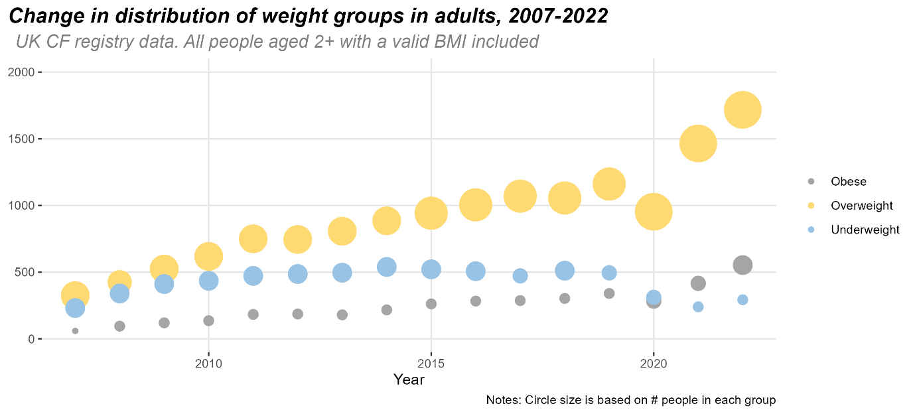
Figure 1: Timeseries of weight categories, adult CF patients between 2007-23
Higher BMIs are associated with better lung function, as measured by FEV1. Increasing BMI in underweight patients has the strongest increase in lung function. Increasing BMI in healthy weight patients (BMIs in the 20 – 25 kg/m2 range) is associated with a much smaller increase in FEV:
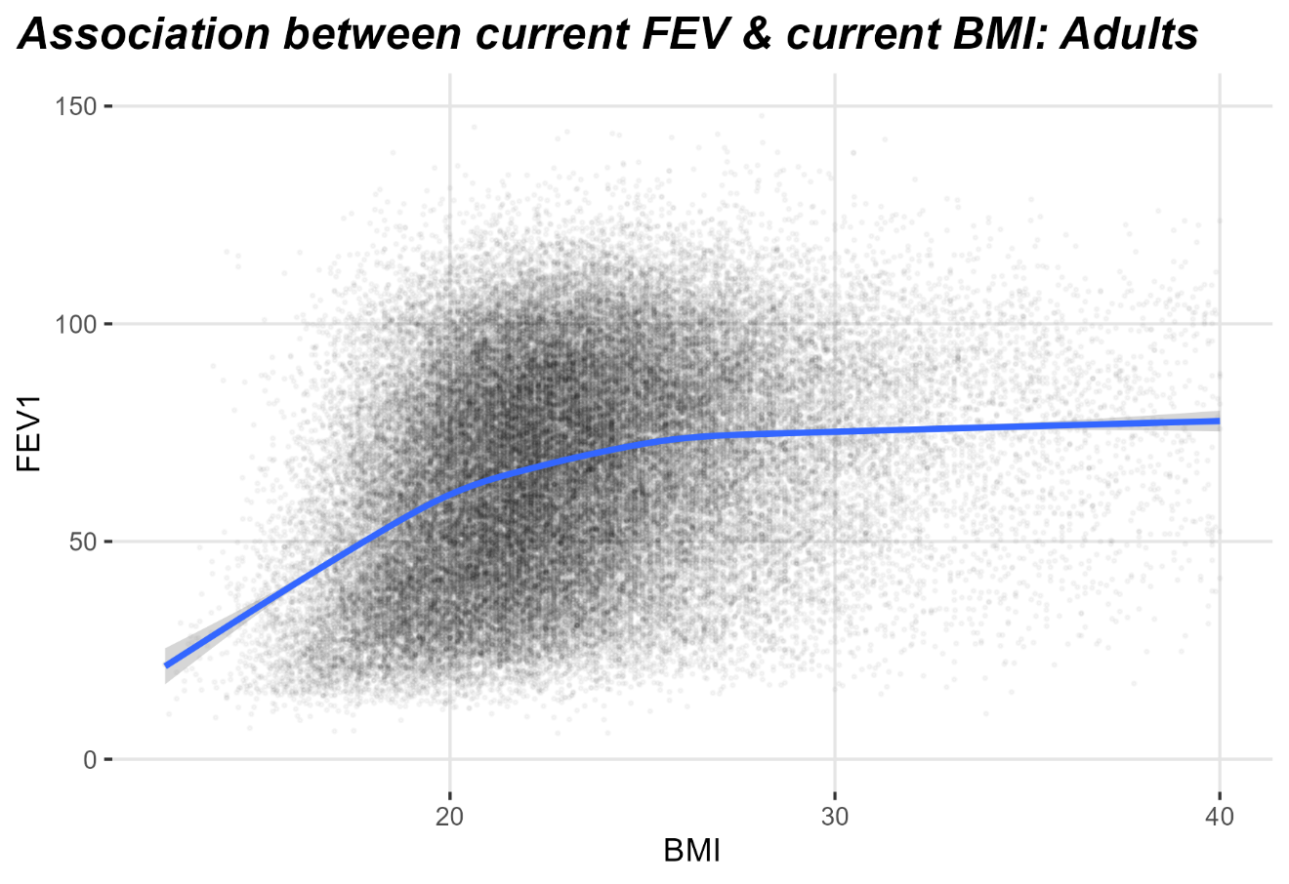
Figure 2: Association between lung function and BMI. Dots are BMI and FEV1 as recorded at each annual review in the CF trust data. The blue line is a lowess smoother showing the general trend in the data.
Figure 3 shows how changing BMI affects FEV1 in more detail. Increasing BMI has the largest positive effect in underweight patients. Increasing BMI in this group is associated with increased FEV1, with BMI increases in the 5 – 7 range being associated with largest increases in FEV1. Further increases in BMI are also associated with increases in FEV1, but these increases are smaller. The underweight adult population have BMIs in the range 16.8 – 18.1 kg/m2, so increasing BMI by 5 – 7 kg/m2 shifts these patients to the middle of the ‘healthy weight’ BMI range. Small increases in BMI are also associated with increases in lung function for the healthy weight group, again as a result of shifting patients at the lower end of ‘healthy weight’ to the middle of the ‘healthy weight’ range. There is no evidence that increasing BMI in overweight or obese patients is associated with increased lung function.
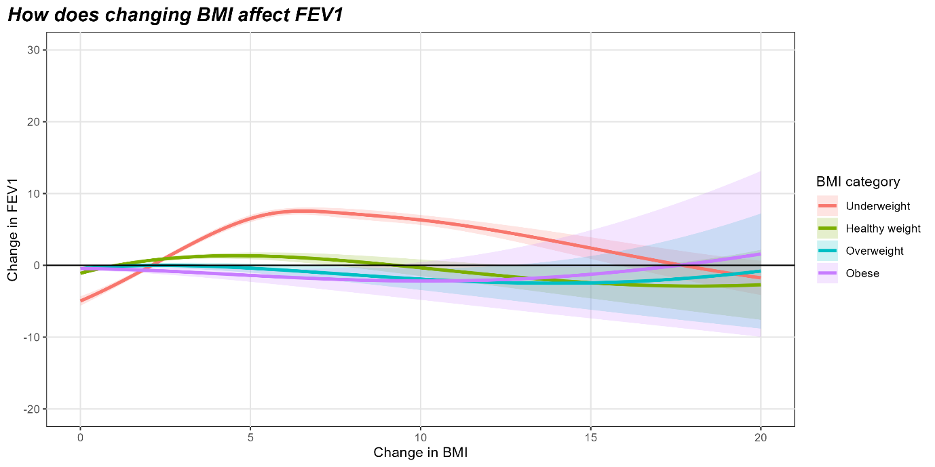
Figure 3: Change in lung function (FEV) as a function of increasing BMI. Solid line shows the predicted change in FEV1 and the shaded regions are 95% confidence intervals.
There is no evidence that the effect of changing BMI varies by sex. We also found no evidence that being on a modulator at the time of review changed the relationship between BMI change and lung function.

Numbers
Children. Median and IQR are based on z-score. Numbers in brackets for the Underweight – Obese columns is the proportion of patients with non-missing BMI in each group. The numbers in the abstract use the total number of patients in each year as the denominator, so the percents are different:
Year | Number | BMI not missing | Median | Interquartile range | Underweight | Healthy weight | Overweight | Obese
2007 | 1,987 | 1,966 | 0.09 | [-0.62, 0.77] | 104  (5.3%) | 1,580  (80.4%) | 213  (10.8%) | 69  (3.5%)
2008 | 2,698 | 2,641 | 0.05 | [-0.65, 0.73] | 150  (5.7%) | 2,143  (81.1%) | 245  (9.3%) | 103  (3.9%)
2009 | 3,361 | 3,231 | 0.04 | [-0.67, 0.72] | 194  (6.0%) | 2,605  (80.6%) | 309  (9.6%) | 123  (3.8%)
2010 | 3,573 | 3,458 | 0.06 | [-0.63, 0.76] | 205  (5.9%) | 2,720  (78.7%) | 367  (10.6%) | 166  (4.8%)
2011 | 3,779 | 3,712 | 0.10 | [-0.59, 0.80] | 222  (6.0%) | 2,936  (79.1%) | 391  (10.5%) | 163  (4.4%)
2012 | 3,840 | 3,788 | 0.09 | [-0.57, 0.77] | 220  (5.8%) | 3,005  (79.3%) | 381  (10.1%) | 182  (4.8%)
2013 | 3,916 | 3,861 | 0.10 | [-0.57, 0.79] | 200  (5.2%) | 3,082  (79.8%) | 410  (10.6%) | 169  (4.4%)
2014 | 3,926 | 3,876 | 0.13 | [-0.57, 0.81] | 206  (5.3%) | 3,046  (78.6%) | 436  (11.2%) | 188  (4.9%)
2015 | 3,967 | 3,926 | 0.14 | [-0.51, 0.80] | 185  (4.7%) | 3,131  (79.8%) | 402  (10.2%) | 208  (5.3%)
2016 | 3,959 | 3,936 | 0.13 | [-0.52, 0.82] | 164  (4.2%) | 3,036  (77.1%) | 436  (11.1%) | 300  (7.6%)
2017 | 3,991 | 3,961 | -0.07 | [-0.92, 0.67] | 653  (16.5%) | 2,656  (67.1%) | 381  (9.6%) | 271  (6.8%)
2018 | 4,010 | 3,987 | 0.11 | [-0.52, 0.79] | 157  (3.9%) | 3,085  (77.4%) | 431  (10.8%) | 314  (7.9%)
2019 | 4,055 | 4,033 | 0.12 | [-0.53, 0.78] | 160  (4.0%) | 3,154  (78.2%) | 405  (10.0%) | 314  (7.8%)
2020 | 4,008 | 3,280 | 0.24 | [-0.43, 0.95] | 115  (3.5%) | 2,445  (74.5%) | 390  (11.9%) | 330  (10.1%)
2021 | 4,003 | 3,712 | 0.30 | [-0.39, 1.01] | 106  (2.9%) | 2,706  (72.9%) | 504  (13.6%) | 396  (10.7%)
2022 | 3,963 | 3,870 | 0.23 | [-0.41, 0.96] | 104  (2.7%) | 2,881  (74.4%) | 502  (13.0%) | 383  (9.9%)
2023 | 3,904 | 3,837 | 0.23 | [-0.42, 0.97] | 111  (2.9%) | 2,838  (74.0%) | 467  (12.2%) | 421  (11.0%)

Adult. Median and IQR are based on BMI. Numbers in brackets for the Underweight – Obese columns is the proportion of patients with non-missing BMI in each group. The numbers in the abstract use the total number of patients in each year as the denominator, so the percents are different:
Year | Number | BMI not missing | Median | Interquartile range | Underweight | Healthy weight | Overweight | Obese
2007 | 2,245 | 2,154 | 21.80 | [19.84, 23.97] | 231  (10.7%) | 1,540  (71.5%) | 324  (15.0%) | 59  (2.7%)
2008 | 3,068 | 2,938 | 21.79 | [19.84, 24.11] | 340  (11.6%) | 2,078  (70.7%) | 425  (14.5%) | 95  (3.2%)
2009 | 3,624 | 3,460 | 21.85 | [19.87, 24.11] | 411  (11.9%) | 2,405  (69.5%) | 524  (15.1%) | 120  (3.5%)
2010 | 3,950 | 3,791 | 21.97 | [19.92, 24.27] | 435  (11.5%) | 2,602  (68.6%) | 618  (16.3%) | 136  (3.6%)
2011 | 4,425 | 4,350 | 22.08 | [20.09, 24.49] | 472  (10.9%) | 2,945  (67.7%) | 750  (17.2%) | 183  (4.2%)
2012 | 4,534 | 4,390 | 22.07 | [20.07, 24.45] | 486  (11.1%) | 2,973  (67.7%) | 745  (17.0%) | 186  (4.2%)
2013 | 4,695 | 4,565 | 22.17 | [20.06, 24.54] | 496  (10.9%) | 3,082  (67.5%) | 807  (17.7%) | 180  (3.9%)
2014 | 5,101 | 4,975 | 22.19 | [20.13, 24.68] | 539  (10.8%) | 3,334  (67.0%) | 885  (17.8%) | 217  (4.4%)
2015 | 5,254 | 5,126 | 22.27 | [20.21, 24.82] | 521  (10.2%) | 3,401  (66.3%) | 942  (18.4%) | 262  (5.1%)
2016 | 5,399 | 5,276 | 22.30 | [20.20, 24.80] | 507  (9.6%) | 3,481  (66.0%) | 1,005  (19.0%) | 283  (5.4%)
2017 | 5,553 | 5,390 | 22.40 | [20.30, 25.00] | 472  (8.8%) | 3,561  (66.1%) | 1,070  (19.9%) | 287  (5.3%)
2018 | 5,525 | 5,488 | 22.40 | [20.30, 24.90] | 511  (9.3%) | 3,618  (65.9%) | 1,056  (19.2%) | 303  (5.5%)
2019 | 5,705 | 5,685 | 22.50 | [20.40, 25.20] | 495  (8.7%) | 3,689  (64.9%) | 1,161  (20.4%) | 340  (6.0%)
2020 | 5,450 | 4,409 | 22.80 | [20.70, 25.30] | 311  (7.1%) | 2,862  (64.9%) | 953  (21.6%) | 283  (6.4%)
2021 | 5,890 | 5,131 | 23.70 | [21.50, 26.40] | 240  (4.7%) | 3,010  (58.7%) | 1,465  (28.6%) | 416  (8.1%)
2022 | 6,021 | 5,905 | 23.70 | [21.40, 26.60] | 293  (5.0%) | 3,342  (56.6%) | 1,717  (29.1%) | 553  (9.4%)
2023 | 6,165 | 6,036 | 23.80 | [21.40, 26.60] | 273  (4.5%) | 3,443  (57.0%) | 1,736  (28.8%) | 584  (9.7%)

